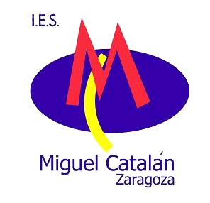

Dear Europroject friends,
Here we are preparing your visit and getting ready for the big, great meeting in May. It is really a challenge for us to prepare such an important event and we feel the responsibility for organizing it as well as you all deserve.

Most of the information about the HEY! meeting is in the ppt which goes with this letter, the same ppt that we showed in Denmark. But here are some other comments to complete it.

The price of the meeting including hotel, all meals, except one, visits and public transport fares will be around 500€ if you are in a single room. For double rooms the price will be 375€.

Apart from that official information we want to offer the possibility to be accommodated in teachers´ houses for those schools that do not have the EON Comenius funding or to those that have run out of money:) Should one of these be your case, please do not hesitate to contact me or Angel explaining what you need.

We expect three teachers from each school : the Headteacher, the net correspondent and one teacher to join the students’ workshops. As the topic of the workshops is Students with behavioural and social problems we would like this teacher to be either a teacher in the Counselling department, or the school psychologist, or someone who knows about it, and can speak English so that he/ she can help our teachers with the workshops since there will be ten different groups of students. We need teachers for thse groups. This is our wish and preference, but again we are flexible on that if it is absolutely impossible for you to bring such a teacher!

Students do not have to pay anything but the travel expenses to Zaragoza. There will be some activities and games for them as well as workshops on the above mentioned topic. An excursion to the Pyrenees and some water sports will also be programmed for students. We expect 4 students from each school, aged 16-17. Not a specific profile is required: we just want sensible, sensitive, sociable and easy-going students who are ready for team work.

In a few days you will receive the Participation Form to be filled in. Please, do not hesitate to ask whatever you may need whether it is about travel, accomodation or any other thing. Either Angel, Maria Luisa or myself will be pleased to help you.

Today is Sunday 11th, when I am writing this. I am still shocked about the terrorist attacks in Paris which left us speechless ....At the same time, this makes us feel how important the unity of all persons in Europe is and how relevant it is to ratify our commitment.

Looking forward to seeing you all here!! Warm greetings on behalf of the Euroteam in our school

Marisé Lacleta

