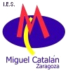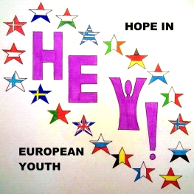
EON CONFERENCE
HEY! – Hope in European Youth
May 5th – May 9th, 2014
Instituto de Educatión Secundaria ’Miguel Catalan’
Zaragoza; Spain

PARTICIPATION FORM
Please confirm your participation and send this form to: Marisé Lacleta mjlacleta@ies-mcatalan.com and to Georg Latzke g.latzke@gmx.at – February 25th at the latest!

Name of School
Names of Teachers (m/f),  Position (e.g. head teacher)  e-mail | 1.
 | 2.
 | 3.
Names of Students (m/f)  Date of birth  e-mail  age: 16 to 17 | 1.
 | 2.
 | 3.
 | 4.
Specifications for arrival:
Specifications for departure:
Number and type of rooms required | ____ single room/s (500€)  ____ double room/s (375€)
Special needs

Please understand that a sent-in participation form means a definite application

